SEO Strategy for climate change projects

1.2.

Grant Agreement No:

101056935 - MAIA - HORIZON-CL5-2021-D1-01

Authors:

**ThatzAd**

Internal reviewer:

**WP7**

|  |  |
| --- | --- |
| Project and Deliverable information | |
| Project Start Date: **01-09-2022**  Duration of the project: **36 months**  Deliverable leader: **Inmedia Solutions** | Dissemination Level (PU,CO, CI): **PU**  Status Draft: **1.2 First public version**  Submission Date: **01-07-2025** |

# Modification control

Control and history of changes:

|  |  |  |  |
| --- | --- | --- | --- |
| **Version** | **Date** | **Description and comments** | **Author** |
| 1.1 | 27-05-2025 | First draft | Thatzad | |
| 1.2 | 18-07-2025 | First public version | Thatzad | |
|  |  |  |  | |

# List of contributors

The contributors of this document are:

* Inmedia Solutions
* Off Course
* ThatzAD

# wHY seo

## INTRODUCTION

Any project, organization, or company that uses a website as a communication channel needs to clearly explain to search engines and AIs what they do or offer.

If search engines see and understand that content, when our target audience searches for what we offer, it will be easier for them to find us.

Projects related to climate change use exactly the same techniques as any other website working on SEO, but keyword selection becomes significantly more important.

In this paper, we aim to provide some techniques and many keyword examples that can be applied to your website with the help of developers.

## SEO Strategy

SEO is the application of various techniques to make our website content more attractive so that search engines in general (and Google in particular, as it dominates the market) rank it higher and give it more visibility.

To do this, we must work on three key processes:

1. Selecting the keywords we are going to work on (**Keyword research**)

2. Giving maximum relevance to those keywords within the content of our website (**Onsite SEO**)

3. Developing the reputation or authority of our website so that search engines see us as more relevant than our competitors (**Offsite SEO**)

# KEYWORD RESEARCH

## Brainstornming

The goal of SEO is to generate traffic from high-quality clients, but the rise of AIs and Google's adaptation to provide direct answers without prioritizing websites means SEO is losing ground for more consultative searches.

The good news is that some types of searches remain relevant—especially when users are looking for a company, product, service, or specific solution.

One of our tasks is to find keywords that meet these three criteria:

* Define us and attract quality potential clients
* Have a relevant search volume on search engines
* Offer an opportunity to rank well compared to the competition (and remember, competition is anything that appears on the first page of Google)

The first step is choosing the right keywords. We recommend using several techniques in this order:

* **Common sense**: what words would your potential clients use to find exactly what you offer? E.g., “climate change projects for the travel sector.”

At the end of this document we have created an Annex with hundreds of keyword ideas on climate change projects.

* **Competitor analysis**: make a list of competitors and see what keywords they use in titles, meta tags, and text. Anyone on the first page of Google for your target keywords counts as a competitor.
* **Keyword tools**: like SE Ranking or Google Ads. These tools suggest new keywords you may not have thought of.

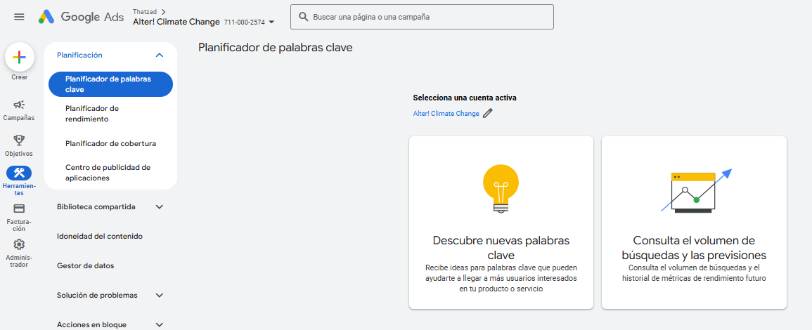

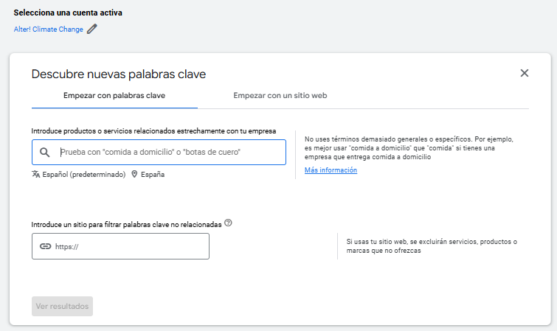

* **Ask ChatGPT**: For example, use this prompt:  
  *“You are an SEO expert. I want you to help me optimize my website. I need you to suggest main, secondary, and long-tail keywords. The website is about a climate change project that does XXXXXX. Here are some keywords I've thought of, but please give me 50 more and rank them by priority.”*
* Once you have your full list, return to those tools to check monthly search volumes and define your strategy. The keywords with the most searches are not always the best. Focus on your business and use common sense.

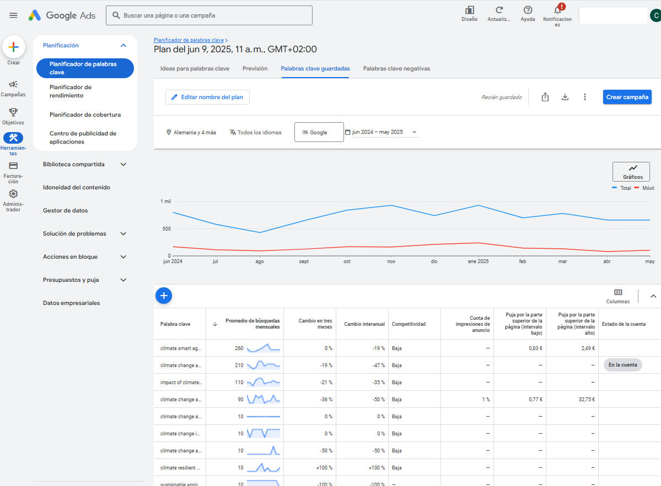

## Keyword Strategy

With all the data collected, we must decide which keywords to develop on the website.

**Generic keywords** may have high search volumes, but without top rankings, they won’t drive traffic.

**Niche keywords** may be easier to rank for but might have too little traffic.

The goal is to find a balance: business-focused keywords that your target clients are likely to search, even if they bring less traffic—it will be higher quality.

We separate them into three groups:

* **Main keywords**: Featured on the homepage and key sections, forming the site’s narrative and used in most inbound links.
* **Secondary keywords**: Featured across the rest of the site. You can’t target a keyword if it’s not dominant on at least one page.
* **Long-tail keywords**: Since page space is limited, these are used in blog posts or news sections. Having a blog is essential for a good SEO strategy.

Only assign **one keyword per page** (two if they go hand-in-hand). If key keywords don’t fit on a current page, consider creating new sections or using blog articles.

At the end of the Paper we have added an Annex with hundreds of keyword ideas for you to find the ones that best suit your project.

# SEO Onsite

**3.1. Website Structure**

Once we define our keyword strategy, we must implement it.

Google better understands a page’s content when keywords appear in specific places. Here they are by priority:

1. Domain (if it contains a keyword)
2. URLs (especially inner pages)
3. Title and meta description (visible on search engines)
4. Headers (H1, H2, H3)
5. Body text (especially at the beginning and end)
6. Anchor text in internal links
7. Image ALT text
8. File names (PDFs, videos, images, etc.)

For general text or visible page content, we recommend reviewing each page and adjusting the text to fit the keyword. Two tips about it:

* Avoid very short texts (minimum 350 words per page)
* Use the keyword 2–3 times per page

It is better understood with the following point where we have prepared some tips for writing blog articles, which is usually the main source of traffic, if we are able to upload 40-50 articles with a good choice of words.

**3.2. How to Write SEO Articles**

Each article should focus on one or two keywords. Don’t try to cover too many in one piece—it’s better to write multiple articles.

1. Keywords should be in the title, preferably at the beginning.  
   Example: If your keyword is “*climate change and aquaculture*,” use something like:  
   *“Climate change and aquaculture: real impact and how to get new opportunities”*
2. Articles should be 500–800 words long. Vary the length based on the topic.
3. Repeat the keyword throughout the article, but no more than 3 times: once at the start, once in the middle, once at the end. Use synonyms or variations elsewhere.
4. The keyword should be repeated throughout the text, but no more than 3 times. It should be at the beginning of the text, in the middle and at the end. In the rest of the text you can also use synonyms or variations of the main keyword. If we go too far, we can be penalised for Keyword stuffing.
5. Use 3–4 subtitles with short paragraphs. Try to include the keyword in one of them.
6. Include at least one image (keep it under 500KB), and make sure the filename or alt-text includes the keyword.
7. Add 1–3 internal links. Try to make the link text a keyword from the destination page.
8. Write naturally and provide value—articles are for people, not just search engines.
9. SEO drives traffic, but your content must convert. Include your value proposition and benefits, and use data or success stories when possible.
10. Always end with a **Call to Action (CTA)** like:  
    *“Email us at XXXXXXXX@CCCC.com for more information”* or *“Register now for a free trial.”*

Creating a large number of sections on the website and many articles is usually a very good strategy to reach more keywords and generate more web traffic.

## Google Page Indexing

Once your pages are optimized, ensure Google indexes them correctly.

* **Google Search Console** is ideal. Create an account, insert a small code on your website, and it shows exactly what Google has indexed.
* If you can’t use it, try free external tools like **Screaming Frog** (<https://www.screamingfrog.co.uk/seo-spider/>)

## Page Load Speed

Google considers page speed in rankings. Corporate websites often aren’t fully optimized but usually aren't too slow either.

The main issue is heavy images. Never exceed 500KB per image—and go lower for less important ones.

Use **PageSpeed Insights** (<https://pagespeed.web.dev/>) to analyze loading speed.

The report usually includes improvement suggestions. Share it with your developers and let them plan changes based on cost/benefit.

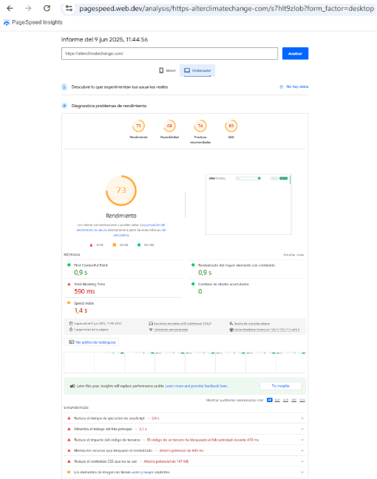

The report usually proposes a series of improvements for the website that we recommend sharing with the programmers. Not all of them can be improved or the cost/benefit may be high, so we recommend that the programmers are the ones who, based on the report, propose a work plan for the website.

# Offsite SEO

## Inbound links to gain Authority

Once keywords are in place and indexed, build authority so Google sees you as a reliable source and ranks you above competitors.

Google assigns authority through **Domain Authority** and **Page Authority**. The more quality inbound links you get, the higher your authority.

An inbound link is any link from other sites to our site. Internal pages (from our own website) are important, but they have much less value than pages from other domains.

And the highest quality links are those that come from websites with a lot of authority, for example a link from a social network has less value than a link from the MAIA website (https://maia-project.eu/), but at the same time has less value than a link from the New York Times (https://www.nytimes.com/) and at the same time has less authority than a link from the UN (https://www.un.org/).

New sites have low authority. You must build it gradually through natural or requested links (directories, public agencies, clients, partners, events, universities, etc.)

# Conclusions

Generating organic traffic is not easy. But if you have something valuable to say and no budget for paid campaigns, SEO is essential.

Three key steps:

* Choose the right keywords you want—and are able—to rank for
* Apply those keywords on your site and create lots of new content (pages or blog articles) to attract traffic through more keywords
* Get quality links from other websites

High-quality content can also be shared on social media, sent via newsletters, or picked up by specialized media.

# annex

We have done a first keyword research grouped by clusters from some SEO tools. It will help you to get ideas that can be adapted to your project and it will be easier for you to develop your own.

**General Climate Terms and Trends**

High-volume keywords for general interest in climate change and global warming.

climate change (550,000)

global warming (550,000)

climate (301,000)

climate crisis (14,800)

climate change news (18,100)

climate change facts (14,800)

climate change article (14,800)

climate change meaning (18,100)

climate change examples (12,100)

climate change report (4,400)

**Causes and Effects of Climate Change**

Keywords focused on the causes and consequences of climate change.

causes of climate change (90,500)

reasons for climate change (90,500)

effects of climate change (74,000)

causes of global warming (49,500)

effects of global warming (40,500)

sea level rise (40,500)

global climate change (33,100)

global warming meaning (33,100)

10 causes of global warming (12,100)

10 effects of climate change (9,900)

**Climate Solutions and Mitigation**

Keywords related to actions and strategies to combat climate change.

climate action (27,100)

climate change solutions (12,100)

climate change mitigation (6,600)

global warming solutions (5,400)

ways to prevent climate change (4,400)

10 ways to reduce climate change (4,400)

climate change prevention (3,600)

climate change initiatives (3,600)

climate change projects (3,600)

climate change programs (3,600)

**Climate Adaptation and Resilience**

Keywords addressing adaptation to climate change and building resilience.

climate change adaptation (9,900)

climate adaptation (5,400)

climate resilience (5,400)

climate change resilience (3,600)

climate adaptation strategies (2,900)

climate resilience planning (2,400)

climate adaptation tools (1,900)

climate resilience framework (1,900)

climate change adaptation measures (1,600)

climate adaptation planning (1,600)

**Agriculture and Fisheries**

Keywords related to the impact of climate change on agriculture and fisheries.

climate change and agriculture (5,400)

impact of climate change on agriculture (8,100)

climate-smart agriculture (3,600)

climate change and food security (2,900)

climate change and fisheries (2,400)

climate change impact on fisheries (1,900)

climate change and aquaculture (1,600)

climate-resilient crops (1,600)

sustainable agriculture and climate change (1,600)

climate change and livestock (1,600)

**Water Resources and Oceans**

Keywords about the effects of climate change on water systems and oceans.

sea level rise (40,500)

ocean acidification (3,600)

climate change and water resources (2,900)

climate change and ocean currents (2,400)

climate change and marine ecosystems (2,400)

climate change impact on oceans (1,900)

climate change and coastal erosion (1,600)

climate change and freshwater availability (1,600)

climate change and hydrology (1,600)

climate change and sea surface temperature (1,600)

**Biodiversity and Ecosystems**

Keywords focusing on biodiversity loss and ecosystem changes due to climate change.

biodiversity and climate change (2,400)

climate change and ecosystems (2,400)

climate change impact on biodiversity (1,900)

climate change and wildlife (1,600)

climate change and deforestation (1,600)

climate change and habitat loss (1,600)

climate change and invasive species (1,600)

climate change and species extinction (1,600)

climate change and conservation (1,600)

climate change and protected areas (1,600)

**Government and Policy**

Keywords regarding climate policies, international agreements, and public sector action.

cop28 (165,000)

unfccc (74,000)

climate change policy (2,400)

united nations climate change (6,600)

climate change agreements (1,900)

climate change legislation (1,600)

climate change governance (1,600)

climate change and public policy (1,600)

climate change and international relations (1,600)

climate change and local governments (1,600)

**Research and Science**

Keywords targeting scientific research, data, and modeling in climate science.

ipcc report (12,100)

climate change research (1,900)

climate science (5,400)

climate change data (2,400)

climate change modeling (1,600)

climate change statistics (1,600)

climate change projections (1,600)

climate change scenarios (1,600)

**Research & Data Platforms**

climate data platforms – 1,000  
climate analytics tools – 800  
climate research marketplace – 150  
climate data marketplace – 200  
climate resilience research – 500  
climate adaptation research – 600  
scientific research on climate change – 1,200  
climate data services – 700  
climate modeling services – 500  
climate data providers – 900

**Companies, Startups & Solutions**

climate research companies – 400  
climate change startups – 1,000  
climate data intelligence – 300  
climate risk data analysis – 350  
AI for climate change research – 250  
machine learning climate models – 300  
remote sensing climate change – 400  
climate forecasting tools – 500  
open access climate research – 600  
climate GIS mapping – 450

**AI, Modeling & Forecasting**

satellite data for climate monitoring – 700  
climate innovation hubs – 200  
climate science consultancy – 300  
climate data visualization tools – 500  
big data for climate change – 400  
climate modeling software – 600  
climate prediction platforms – 450  
climate risk modeling – 550  
climate intelligence services – 350  
climate technology solutions – 800

**Tools, Portals & Knowledge Hubs**

climate adaptation tools – 500  
climate resilience evaluation tool – 400  
climate data portals – 600  
climate change knowledge portal – 700  
climate change data catalog – 300  
climate vulnerability index – 350  
climate change indicators dashboard – 450  
climate adaptation planning tool – 400  
climate risk assessment tools – 500  
climate change mapping tools – 550

**Other longtail keywords**

climate change data platforms

climate change analytics tools

climate change research marketplace

climate data marketplace

climate resilience research

climate adaptation research

scientific research on climate change

climate change data services

climate modeling services

climate change data providers

climate research companies

climate change startups

climate data intelligence

climate risk data analysis

AI for climate change research

machine learning climate models

remote sensing climate change

climate change forecasting tools

open access climate change research

climate change GIS mapping

satellite data for climate monitoring

climate change innovation hubs

climate science consultancy

climate data visualization tools

big data for climate change

climate change modeling software

climate change prediction platforms

climate-related risk modeling

climate intelligence services

climate change technology solutions